## ****Why Tableau?****

Below are some of the pros or features of Tableau which will spellbind you to start using it right away!

**Tableau Features:**

**1. Apt visualizations:**

Tableau connects to many different data sources and can visualize larger data sets than Power BI can. Once in Tableau, a dashboard shows the basics of the users’ data. The user can then drill down into data sets by downloading a worksheet. From there, they can apply various visualizations to the data.

In Tableau, you select the data and switch between visualizations on the fly. It’s easier to jump between visualizations in Tableau.

Tableau visualizes data from the start, allowing you to see the significance right away. Tableau differentiates correlations using color, size, labels and shapes, giving you context as you drill down and explore on a granular level.

**2. Depth of discovery:**

The features of Tableau gives users ways to answer questions as they investigate data visualizations. The solution can show basic trends as predictions, use “what if” queries to adjust data hypothetically, and visualize components of data dynamically for comparisons.

**3. Implementation:**

Tableau provides a variety of implementation and consulting services. For enterprise-level deployment, there’s a four-step process spanning weeks, and for smaller-scale deployments, there are quick-start options that can complete setup in a matter of hours.

Tableau provides a variety of implementation and consulting services. For enterprise-level deployment, there’s a four-step process:

* Phase 1 – This phase involves IT planning, architecture consulting, pre-install checkup, server installation and verification, and validation of security configuration.
* Phase 2 – Phase 2 involves working with data and data migration, including data modeling, data mining, data extraction, data sources and business workflow.
* Phase 3 – In Phase 3, there’s a two-day classroom training covering Tableau Fundamentals, hands-on advanced coaching, and building and formatting visualizations.
* Phase 4 – This final phase helps companies expand Tableau usage across their business. It includes implementation workshops where topics such as evaluating action plans and defining measurable outcomes are discussed.

**4. Automation functionality:**

Tableau is a little more intuitive with creating processes and calculations. For example, when creating calculations in a tabular format, the formula can be typed once, stored as a field and applied to all rows referencing that source. This makes it easier to create and apply recurring processes. Tableau’s flexibility also allows users to create custom formulas that aren’t available in most of the tools.

**5. Data source connectors:**

Tableau offers hundreds of native connectors to easily pull, cleanse and correlate data from practically any source without having to create custom code.

Tableau extracts large data sets from sources for quick, ad-hoc analysis using two different methods: Live Connection and In-memory. Both adapt to your local database and, based on the size and capacity, sync data quickly by extracting the relevant data to a query. It also has a general Open Database Connectivity (ODBC) connection for any connections that don’t have a native connector provided.

**Tableau - Design Flow**

Needs a very meticulous planning to create a good dashboard or story. hence it is important to know the approach to design a good dashboards. Like any other field of human endeavor, there are many best practices to be followed to create good worksheets and dashboards.

Though the final outcome expected from a Tableau project is ideally a dashboard with story, there are many intermediate steps which need to be completed to reach this goal. Below is a flow of design steps that should be ideally followed to create effective dashboards.

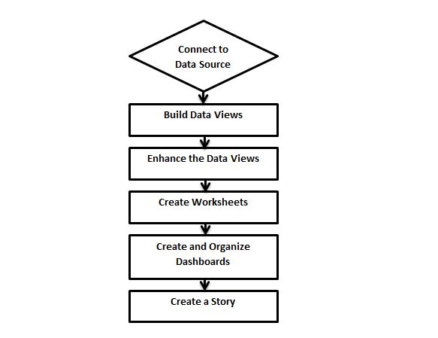

## Connect to Data Source (read data from sources – Excel, CSV, Oracle, MS SQL Server etc.)

-CSV: comma separate version

Tableau connects to all popular data sources. It has inbuilt connectors which take care of establishing the connection once the connection parameters are supplied. be it **Simple text files, Relational sources, No Sql sources or Cloud data bases**, tableau connects to nearly every data source.

## Build Data Views

After connecting to a data source, you get all the column and data available in the Tableau environment. You classify them as dimensions (text/non-calculative), measures (caculative/numeric) and create any hierarchy required. Using these you build views which are traditionally known as Reports. Tableau provides easy drag and drop feature to build views.

**Dimensions:** non-numeric column/non-calculated column example: Name, Address, Gender etc.

**Measures:** numeric column / calculated column

## Enhance the Views

The views created above needs to be enhanced further by use of filters, aggregations (function), Labeling of Axes, Formatting of colors and borders etc.

## Create Worksheets/Report (visualization of data)

We create different worksheets to create different views on the same data or different data.

## Create and Organize Dashboards (collection of worksheets)

Dashboards contain multiple worksheets which are linked it. So the action in any of the worksheet can change the result in the dashboard accordingly.

## Create a Story

A story is a sheet that contains a sequence of worksheets or dashboards that work together to convey information. You can create stories to show how facts are connected, provide context, demonstrate how decisions relate to outcomes, or simply make a compelling case

## ****Tableau Product Family****

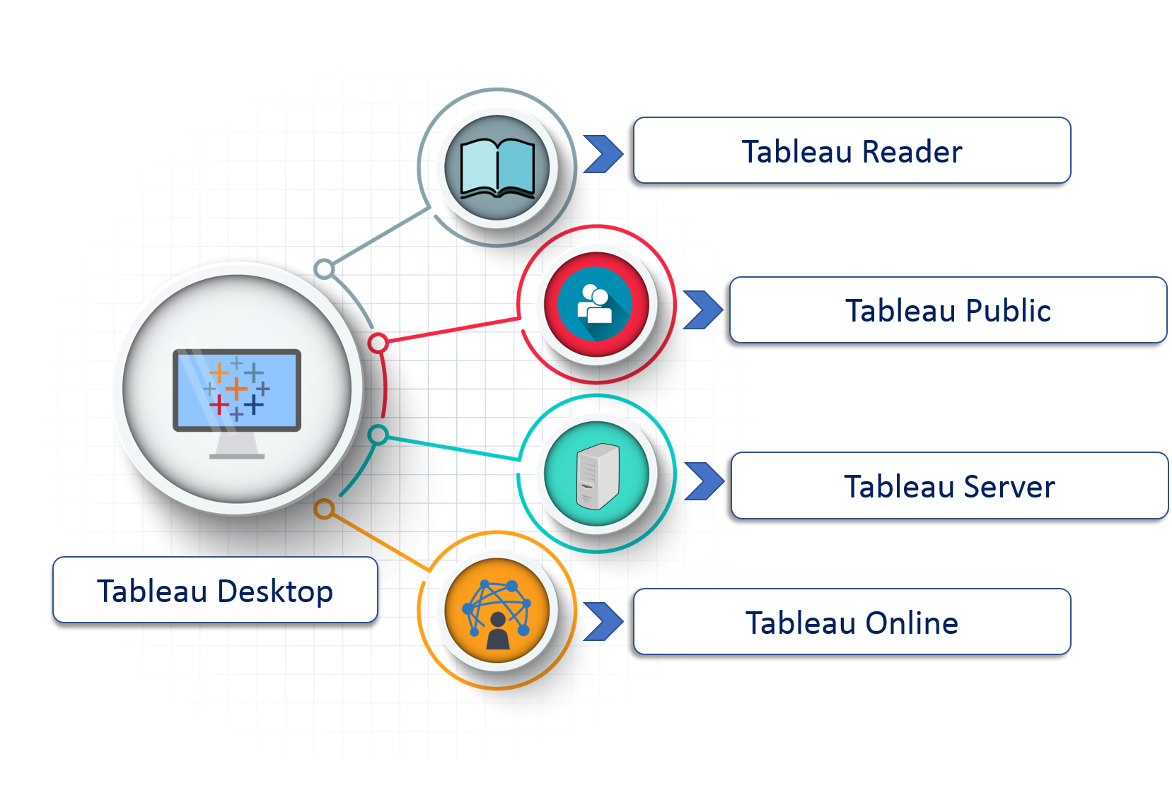**1. Tableau Desktop:**

It is a self service business analytics and data visualization that anyone can use. It translates pictures of data into optimized queries. With tableau desktop, you can directly connect to data from your data warehouse for live upto date data analysis. You can also perform queries without writing a single line of code. Import all your data into Tableau’s data engine from multiple sources & integrate altogether by combining multiple views in a interactive dashboard.

**2. Tableau Server:**

It is more of a enterprise level Tableau software. You can publish dashboards with Tableau Desktop and share them throughout the organization with web-based Tableau server. It leverages fast databases through live connections.

**3. Tableau Online:**

This is a hosted version of Tableau server which helps makes business intelligence faster and easier than before. You can publish Tableau dashboards with Tableau Desktop and share them with colleagues.

**4. Tableau Reader:**

It’s a free desktop application that enables you to open and view visualizations that are built in Tableau Desktop. You can filter, drill down data but you cannot edit or perform any kind of interactions.

**5. Tableau Public:**

This is a free Tableau software which you can use to make visualizations with but you need to save your workbook or worksheets in the Tableau Server which can be viewed by anyone.